B.Sc. (Hons). Computer Science and Software Engineering

University of Bedfordshire

**Software Requirements Specification**

for

**Certichain**

**Proposal, Technical Project**

**Group 10**

Client Mr. Ravi Muditha

Version 1.0

Prepared by: Group 10

Table of Contents

1. INTRODUCTION 1

1.1. Purpose 1

1.2. Intended Audience and Reading Suggestions. 1

1.3. Product Scope 2

2. OVERALL DESCRIPTION 3

2.1. Product Perspective 3

2.2. Product Functions 4

2.3. User Classes and Characteristics 5

2.3.1. Administrator / Staffs 6

2.3.2. Customer 6

2.4. Implementation and Development Requirements 6

2.5. Design and Implementation Constraints 7

2.6. User Documentation 8

2.7. Project Documentation 8

2.8. Assumption and Dependencies 8

2.9. User Interfaces 9

2.10. Hardware Interfaces 9

2.11. Software Interfaces 9

2.12. Communication Interfaces 9

3. SYSTEM FUNCTIONAL SYSTEMS 10

3.1. Database Requirements 10

3.2. Use Case Description. 10

4. NON – FUNTIONAL REQUIREMENTS 11

4.1. ANY HEADINGS THAT SUITESOUR PROJECT CAN ADD 11

4.2. DDD 11

4.3. XSX 11

4.4. Software Quality Attributes 11

# INTRODUCTION

## Purpose

The client we have chosen for this module is Santha Rita, an educational institute based in Naples, Italy. This institution boasts an impressive number of students from all walks of life. Whenever a students completed their education program they will be awarded with a certificate that inscribes their academic achievements. As of the present there exists no system to verify the authenticity of these provided certificates. This in turn has given rise to a multitude of issues such as duplication of certificates, impersonation of identities and fraudulent behavior in general. As this is an issue that directly weighs on the credibility of this prestigious institution, the development team has proposed a website which has a functionality of verifying the validity of the certificates. The implementation of the proposed website will also ensure that an irrecoverable loss of certificates will not occur in the future. Upon the implementation of the proposed website the users, administrators and students at the institute will be able to view, upload and recover any certificate as long as they have a stable internet connection.

This Software Requirement Specification document or SRS document is presented at this point for the purpose of presenting a detailed description of the Certichain website. This document contains an overview of the SRS, the project scope, a description of the proposed project, the functionalities and the functional and non-functional requirements, and interface requirements. Everything that is presented through this document transpired upon decisions made after having client meetings. The SRS document will also justify how this website will positively impact the institute and the users of the website.

## Intended Audience and Reading Suggestions.

This website is created for an educational institute based in Naples, Italy. The proposed website will improve the user experience of the institute’s officials who will be administrative users of the website and other individuals of interest. As for this document, the developers, testers, stakeholders, users, and other interested individuals constitute the intended audience.

Brief Outline of this document;

* Description of the system.
* Functionalities of the website.
* User Interfaces.
* Non-functional requirements.

This proposed website does not require that a user must be an expert at technology to navigate. It will be implemented in an easy to understand, easily accessible manner with the only major requirement being possessing an internet connection.

## Product Scope

The primary objective of the proposed project is to implement a system to easily authenticate and access the certificates provided by the Santha Rita institute.

User Authentication, Certificate Uploads, Blockchain Integration, Search and Retrieval, Access Controls, Alerts and Notifications are the major functionalities included on the website.

# OVERALL DESCRIPTION

## Product Perspective

Santha Rita is an education institute based in Naples, Italy. This institute is in need of a website to authenticate the validity of the certificates they provide at the completion of their academic courses. Through this website the students and other interested parties should be able to certify that their documentation is valid. Currently no such mechanism exists and has therefore caused a plethora of issues, such as, duplication, lack of redundancy and irrecoverable loss of the certificates. The proposed system is one that plans to incorporate the top-of-the-line existing blockchain technologies to yield a product that satisfies the entirety of the client requirements. This website will house an easy-to-use user interface to provide the best user experience accessible from anytime, anywhere. Further descriptions of the system will be provided through the illustrations and diagrams further on in this document.

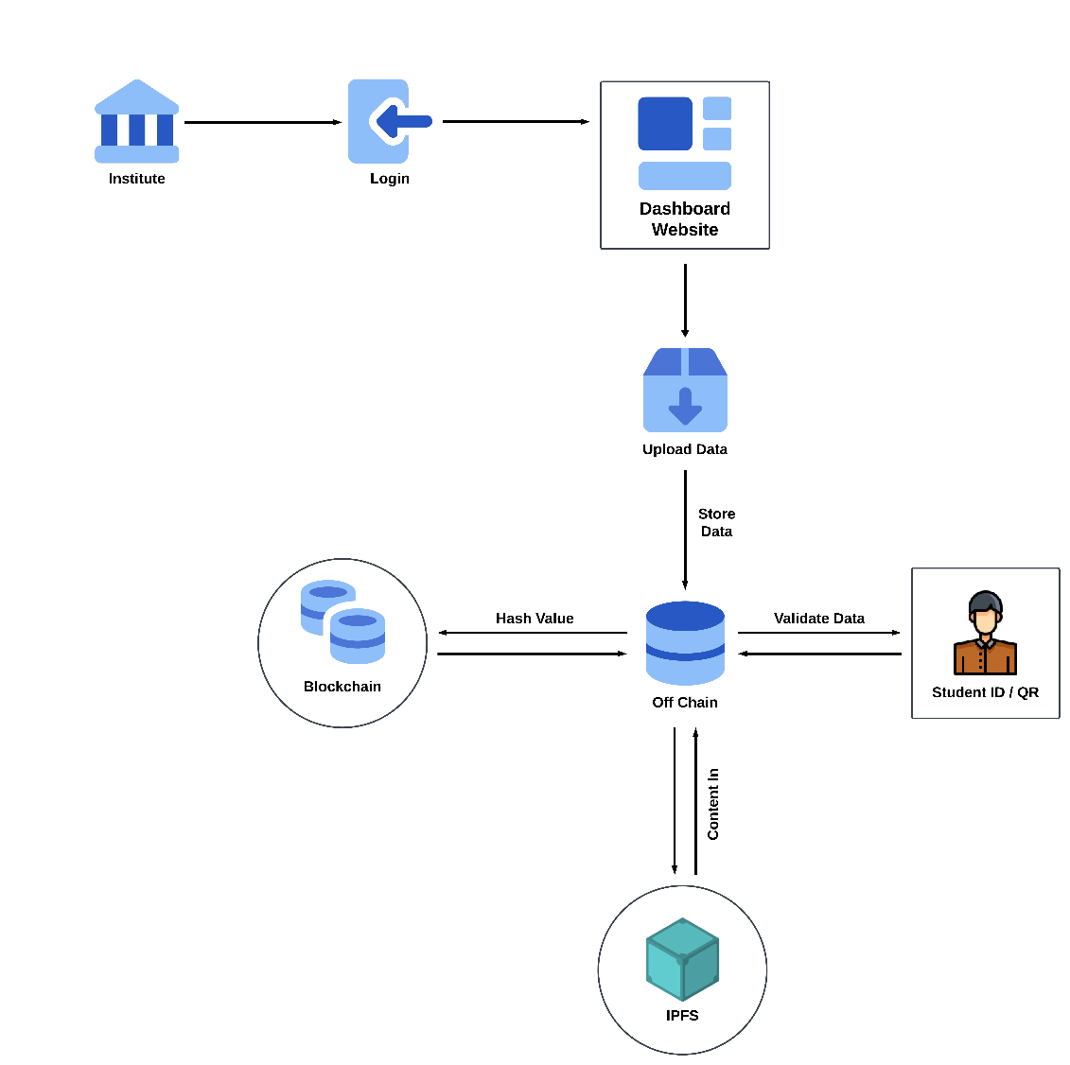

Figure 2.1: Architecture Diagram of The Project

## Product Functions

The website will enable the end users to be able to authenticate and re-access their certificates. This will also allow the administrators to manage the existing certificates provided by the institution.

The functions of the proposed website in brief;

* User Authentication and different permission levels depending on the nature of the account.
* Facilitation of certificate uploads.
* Integration of blockchain technology.
* Verification of certificates.
* Role based access controls.
* User activity audits
* Alerts and notifications.

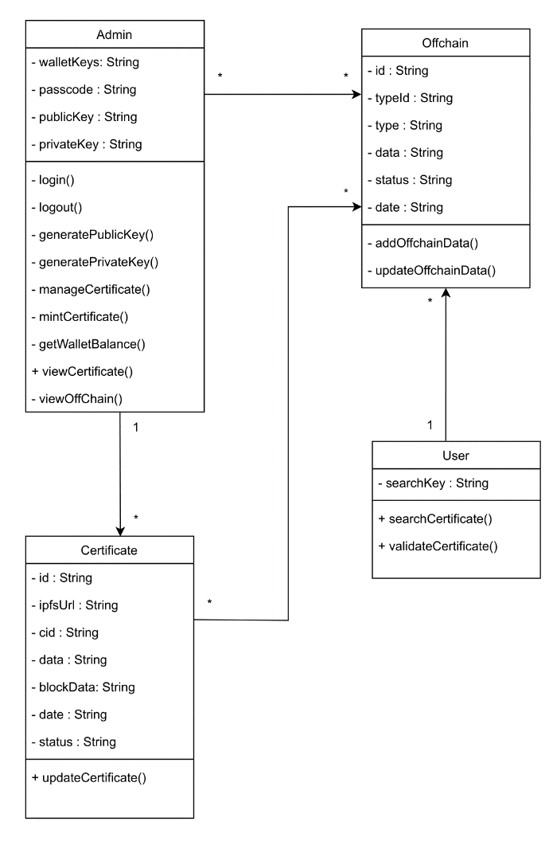

Figure2.2: Class Diagram

## User Classes and Characteristics

There are only two user levels on this website.

1. Administrator / Staffs
2. Students

### Administrator / Staffs

Administrators or staffs have the ability to

* Login and logout
* Manage existing certificates.
* Upload academic certificates.
* Search and retrieve certificates.
* Access permission controls,
* Receive real time updates.

### Customer

Students have the ability to

* Input ID or scan QR
* Validate Certificates.
* View Certificates.

## Implementation and Development Requirements

1. Software Requirements

* MySQL Server
* Visual Studio Code
* Libraries- Bootstrap
* Microsoft word
* Microsoft PowerPoint
* Windows 7 / MAC OS X or above
* IPFS
* Harmony Blockchain

1. Hardware requirements

* PC
* WIFI router
* CPU i3 or above
* RAM - 4GB or above
* Disk - 20GB.

1. Running Environment Requirements

Recommended requirements:

* Windows 10 / Mac OS X Desktop
* 2 GHz or above processor
* 32 / 64 – bit processor
* Disk - 20GB.
* Web browser

## Design and Implementation Constraints

* **Technology Stack:** The recommended website will be made using HTML, JavaScript, Bootstrap and PHP with the Visual Studio Code integrated development environment. To manage and store data, one requires the MySQL database system.
* Technologies:
* Web programming technologies – HTML, CSS, JavaScript, PHP
* Framework – PHP Laravel, Bootstrap
* Libraries – Font Awesome
* Database – MYSQL
* Diagram tools – Draw.IO.

TO PASINDU: ASK FROM MANISH AND FINALIZE.

* **Accessibility Focus:** Through the creation of this website the development team plans to create a system accessible to anyone, anywhere, irrespective of their geological location and their skill in technology. It will boast an easy to use and easy to comprehend user experience in order to ensure that the maximum demographic of users will be able to use the website.
* **Internet Connection:** The main requirement to access the website is to have a stable internet connection. Therefore, we can ensure that any individual with an internet connection can access the website irrespective of where they are geologically from.
* **Organizations Responsibility:** The institution must take the responsibility for the software's Maintenance post-delivery. This entails keeping the website’s security up to date, maintaining the website’s performance, updating the website when required, taking care of any problems or errors.
* **Infrastructure Requirements:** The system requires high availability blockchain nodes and application servers with ample processing and storage.
* **Timeline and Customer Satisfaction:** The factor deciding the success of this exercise is the level of customer satisfaction, therefore if the need presents itself the time frame will be altered to facilitate maximum customer satisfaction.

## User Documentation

As previously mentioned in the upcoming section (2.8 Assumptions and Dependencies) at the point of implementation of the proposed website the development team proceeds upon the assumption that the end user will be familiar with a basic comprehension of the internet. But in the interest of further improving the ease of use the users will be given an introduction and a training session through which the development team intends to provide the guidelines to using the website. Furthermore, a user manual written in a simple easily comprehensible manner will be provided to the users at the event of the launch. The client will also receive a copy of such a hard copy of the user manual along with the product delivery.

## Project Documentation

This section of the document will focus on the documentation produced by the team members so far in their progress of the proposed project. Namely the project brief and the project proposal.

* **Project Brief:** The project brief is the document that serves as a point of reference to what the proposed project will entail once completed. The brief helps to bridge the gap between the client and the development team and ensure a common understanding exists between the two parties pertaining to the project.
* **Project Proposal:** The project proposal focuses on the issue faced by the client and discusses the solution that the development team proposed to implement in order to solve the problem the client is faced with.

## Assumption and Dependencies

* The end users are in possession of a suitable device (such as: A mobile, a desktop computer or a laptop) that allows them to access the proposed website through a web browser.
* The end users have the means to access the internet safely and conveniently.
* The end users have a basic comprehension of the internet, the web browsers and how to use them.
* The end users are aware of how to protect their virtual identity while traversing the internet.

## User Interfaces

TO PASINDU:

HELP WITH DESCRIPTIONS IF YOU CAN

NEEDED THE UI DESCRIPTIONS. REFER TO THE PREVIOUS PAST PUPIL DOCUMENTS.

TO MANISH: PROVIDE THE UI/WIREFRAMES TO WICKY TO WRITE THE DESCRIPTION.

OUTCOME: NEED THE UI AND DESCRIPTION.

## Hardware Interfaces

TO PASINDU : NEED DESCRIPTION

## Software Interfaces

TO PASINDU : NEED DESCRIPTION

## Communication Interfaces

TO PASINDU : ASK FROM MANISH AND FILL OUT

# SYSTEM FUNCTIONAL SYSTEMS

## Database Requirements

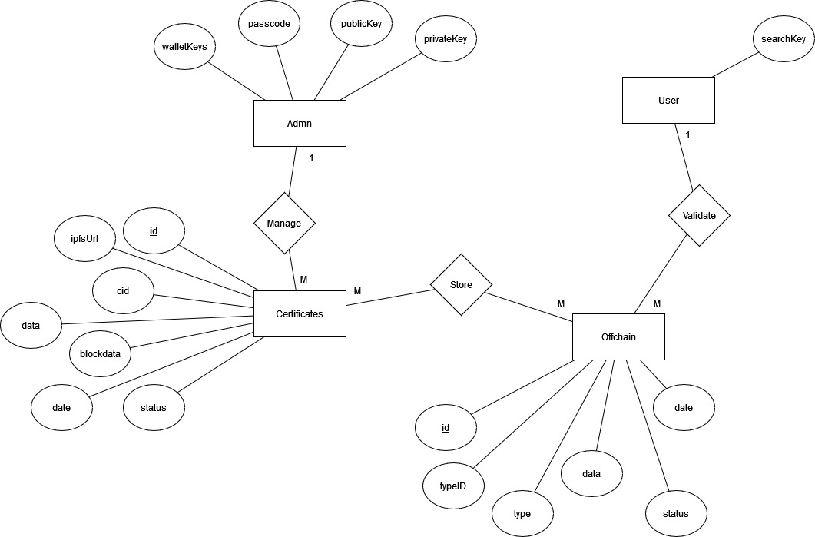

## Use Case Description.

TO WICKY : USE CASE SCENARIOS WITH ACTIVITY DIAGRAM

# NON – FUNTIONAL REQUIREMENTS

AND NON FUNCTIONAL WITH ACTIITY DIAGRAM

## ANY HEADINGS THAT SUITESOUR PROJECT CAN ADD

## DDD

## XSX

## Software Quality Attributes

TO PASINDU: IF POSSIBLE HELP WICKY WITH CONTENTS